Southern New Hampshire University

6-1 Coding Assignment: Modifying Vulnerability Reporting

David Vega

Dr. Vivian Lyon

CS-305 Software Security

02/12/2023

# Pre-suppression link

The below link is the pre-suppression link before reconfiguration of the pom.xml file and inclusion of the suppression.xml file in the module six (6) code base. A separate html file to the report has been provided outside of this document.

**file:///Users/davidvega/Library/CloudStorage/OneDrive-SNHU/CS-305_SNHU/Mod6/dependency-check-report_BEFORE.html**

Figure 1: Pre-suppression

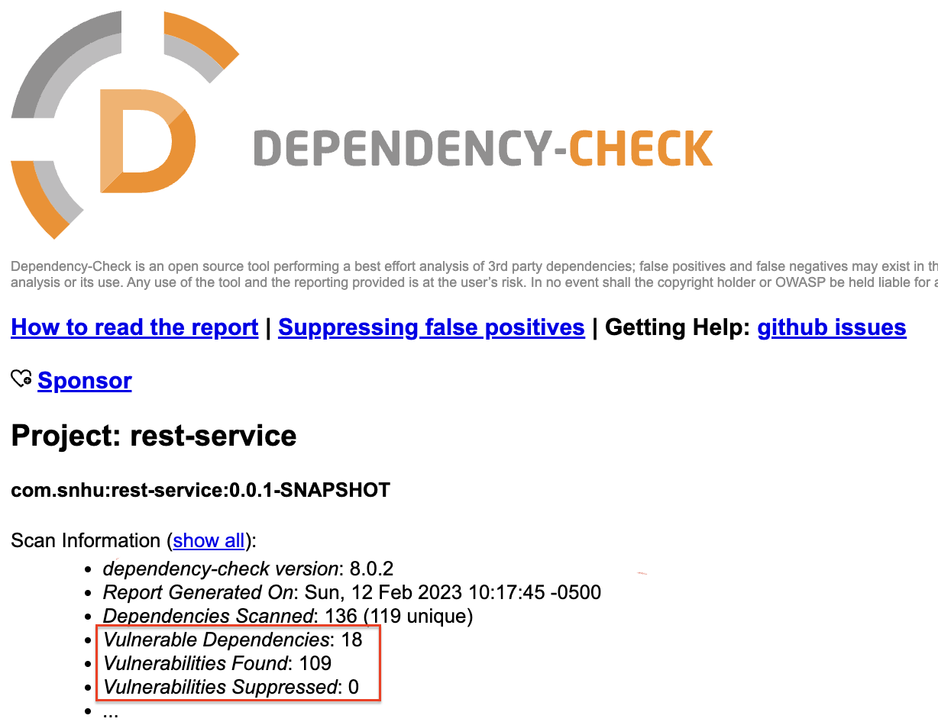

*Screenshot courtesy of OWASP dependency check tool*

# Post-suppression link

The below link is the post-suppression link after the reconfiguration of the pom.xml file and inclusion of suppression.xml file in the module six (6) code base. A separate html file to the report has been provided outside of this document.

<file:///Users/davidvega/Library/CloudStorage/OneDrive-SNHU/CS-305_SNHU/Mod6/dependency-check-report_AFTER.html>

Figure 2: Post-suppression

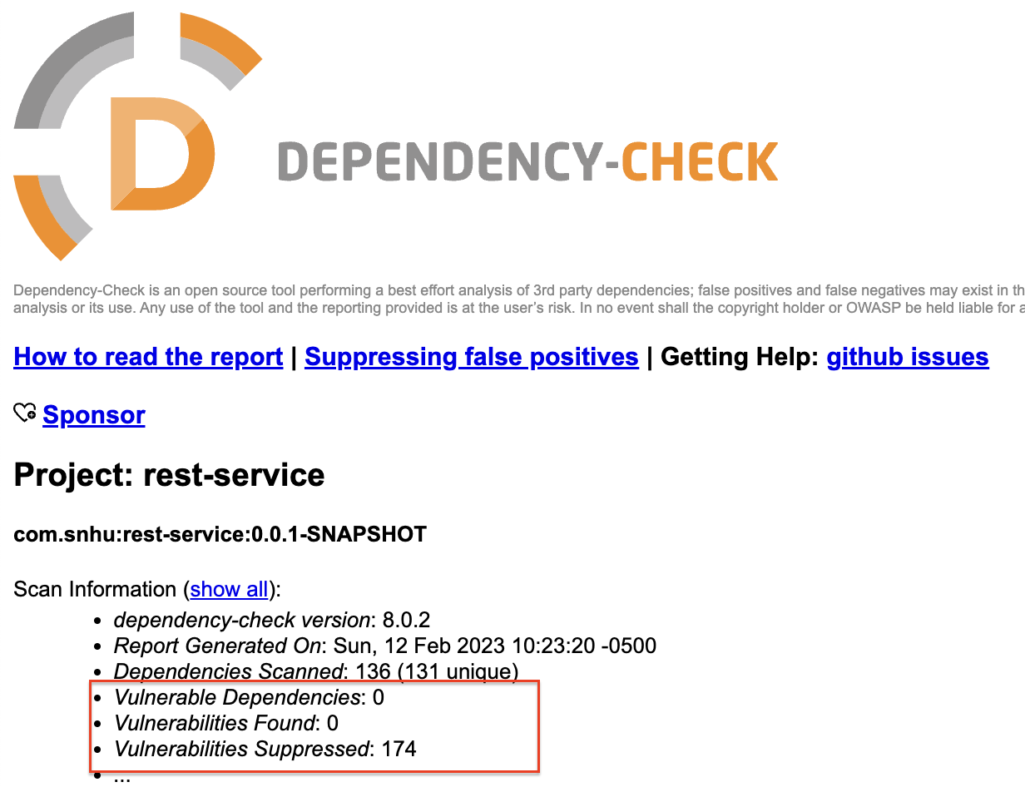

*Screenshot courtesy of OWASP dependency check tool*

# References

OWASP Project. (2023, February 1). *OWASP Dependency-Check 8.0.2*. Retrieved February 2023, from owasp.org: https://owasp.org/www-project-dependency-check/